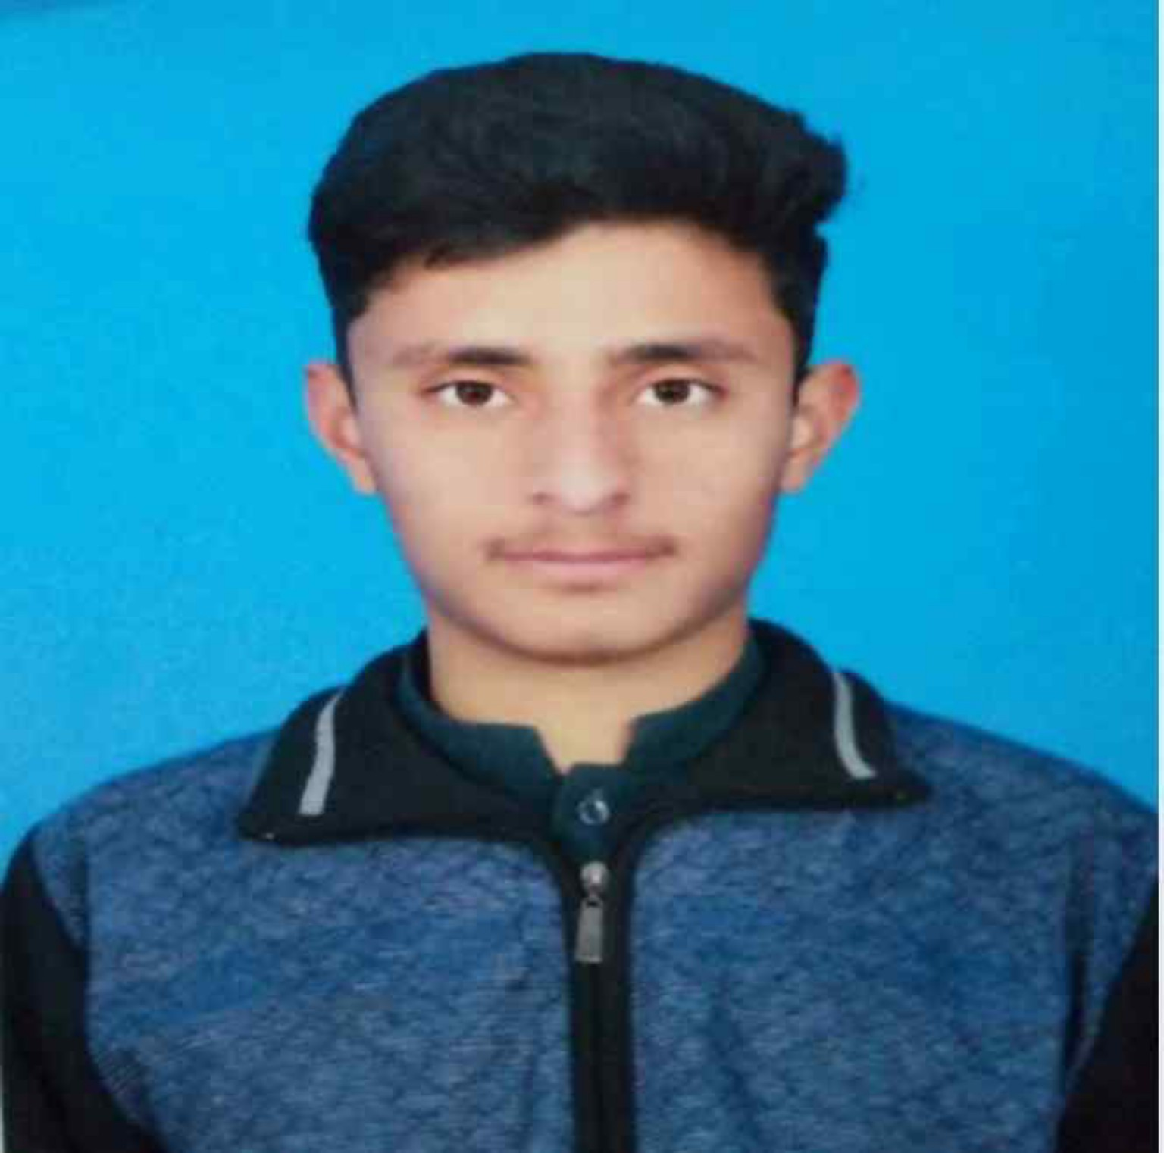 | SAIF ULLAH KHAN  Software Engineering Student · Full-Stack Development · DSA & AI Fundamentals  saifullah02727@gmail.com | 0310-5591848 | Kamra, Pakistan

Professional Summary
Motivated and dedicated Software Engineering student at Air University, Kamra Campus with a strong foundation in programming, data structures, and database systems. Proficient in C++, Python, HTML, and SQL, with hands-on experience building academic-grade management systems. Actively expanding knowledge in AI fundamentals and full-stack development. Eager to apply technical skills to real-world challenges and contribute to innovative software projects through internships and collaborative opportunities.
Education
Bachelor of Science in Software Engineering (BSSE) Expected: 2028
Air University — Aerospace & Aviation Campus, Kamra, Pakistan
Current CGPA: 2.38 | Relevant Coursework: Data Structures & Algorithms · Object-Oriented Programming · Database Systems · Web Development · Artificial Intelligence
Technical Skills
Languages  C++  Python  HTML  SQL  Assembly (x86) | Tools & Platforms  MySQL  Git & GitHub  Visual Studio  Canva / MS Office | Core Concepts  DSA & Problem Solving  OOP & Design Patterns  Database Design  Web Development Basics  AI Fundamentals
Projects
Riding Management System C++ · DSA
Lead Developer — Academic Project
- Developed a console-based management system to organize and manage ride operations, applying core data structures including arrays and linked lists for efficient data handling.
- Implemented sorting and searching algorithms to optimize driver and passenger lookups, improving overall system response efficiency.
- Enforced modular OOP architecture with clear class hierarchies, ensuring maintainability and scalability of the codebase.
- Conducted algorithmic complexity analysis to identify and resolve performance bottlenecks across core modules.
School Billing System C++ · MySQL
Full-Stack Developer — Academic Project
- Designed a billing and fee management system to track student payment records, dues, and receipts with a structured database backend.
- Built CRUD operations with parameterized queries to ensure data integrity and prevent common SQL vulnerabilities.
- Automated fee calculation and record generation, reducing manual data entry effort and improving accuracy.
Gym Management System Python · MySQL
Developer — Academic Project
- Designed a management solution for handling gym member records, membership plans, and operational tasks.
- Implemented member registration, attendance tracking, and subscription management with a normalized database schema.
- Created a simple user interface for staff to manage day-to-day operations without technical expertise.
Certifications & Learning
AI For Everyone – Coursera (March 2024)  Python for Everybody – Coursera (February 2024) | Data Structures & Algorithms (Self-study)  Web Development Fundamentals (Self-study)
Languages & Interests
Languages: English (Fluent) · Urdu (Native) | Interests: Software Development · Artificial Intelligence · Problem Solving · Emerging Technologies

